INTERNET OF THINGS (IoT) — RESEARCH REPORT
IoT in Smart Agriculture
Revolutionizing Farming Through Connected Technology
Task 1 — CodeAlpha IoT Internship

1. Introduction:
The Internet of Things (IoT) refers to a network of physical devices embedded with sensors, software, and connectivity that enables them to collect and exchange data over the internet. Over the past decade, IoT has emerged as one of the most transformative technologies across multiple sectors — and agriculture is no exception. Agriculture remains the backbone of many developing economies, including Pakistan, where over 37% of the labor force is employed in this sector. However, traditional farming methods face mounting challenges such as water scarcity, unpredictable weather, soil degradation, and low crop yields. Smart Agriculture — powered by IoT — offers a data-driven solution to these problems, enabling farmers to make informed decisions in real time and use resources more efficiently.

2. What is IoT in Agriculture?
IoT in agriculture, often referred to as smart agriculture or precision farming, involves deploying a network of interconnected sensors, devices, and software platforms across farmland to collect and analyze data continuously. These devices monitor variables such as soil moisture, temperature, humidity, crop health, and livestock conditions, then transmit this information over the internet to centralized systems where it can be processed and turned into actionable insights. Instead of farmers relying purely on intuition or fixed schedules, IoT allows decisions to be guided by real, live data from the field itself.

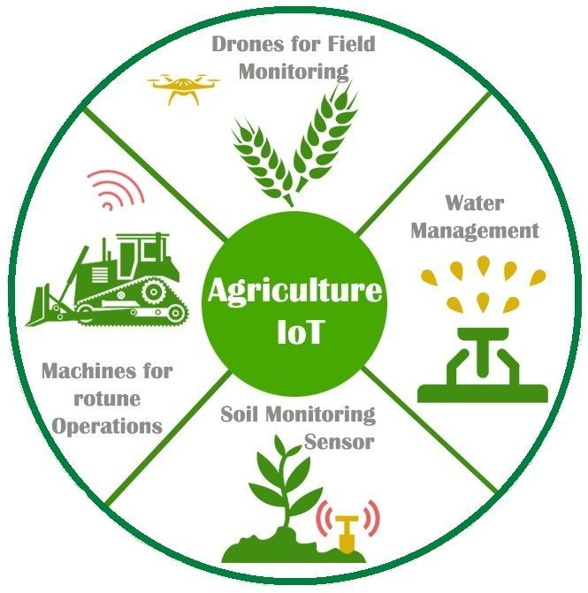

2. Key IoT Applications in Smart Agriculture:
2.1 Soil Monitoring:
IoT-based soil sensors measure critical parameters such as moisture level, temperature, pH, and nutrient content. These sensors are placed at various depths across the field and transmit data wirelessly to a central dashboard. Farmers can monitor soil health in real time and decide when and where to apply water or fertilizer — reducing waste and improving crop quality.
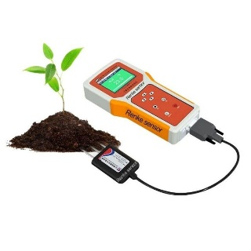

2.2 Automated Irrigation Systems:
Water scarcity is a critical issue in South Asia. IoT-enabled smart irrigation systems use soil moisture data combined with weather forecasts to automatically control water flow. Instead of irrigating on a fixed schedule, the system activates only when needed — conserving up to 30–50% of water compared to traditional methods. Companies like Netafim and CropX have developed such systems used globally.
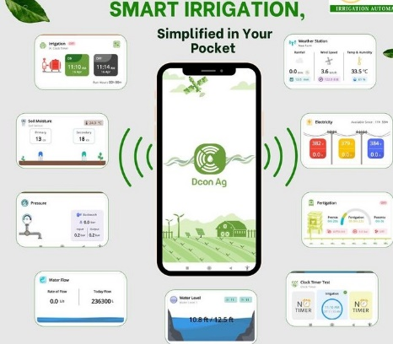

2.3 Drone-Based Crop Monitoring:
Agricultural drones equipped with multispectral cameras and IoT sensors fly over fields to capture detailed imagery. This data is processed using AI algorithms to detect pest infestations, nutrient deficiencies, and crop stress at an early stage. Farmers can then take targeted action rather than applying pesticides across the entire field, saving cost and reducing chemical usage.
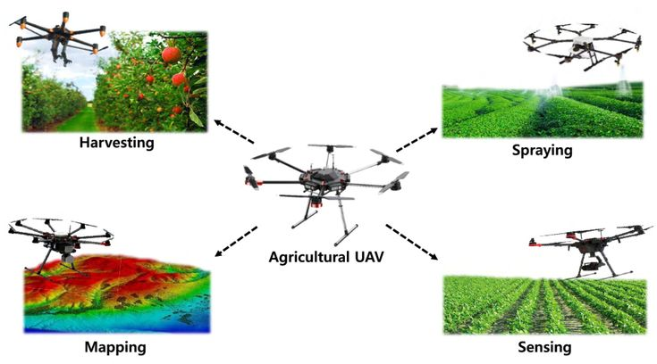

2.4 Weather Monitoring Stations:
Local IoT-based weather stations placed on farms measure temperature, humidity, rainfall, and wind speed. Unlike general weather forecasts, these hyperlocal readings are specific to the exact field, allowing farmers to plan planting, harvesting, and spraying schedules accurately. Integration with mobile apps provides instant alerts for frost, drought, or storms.
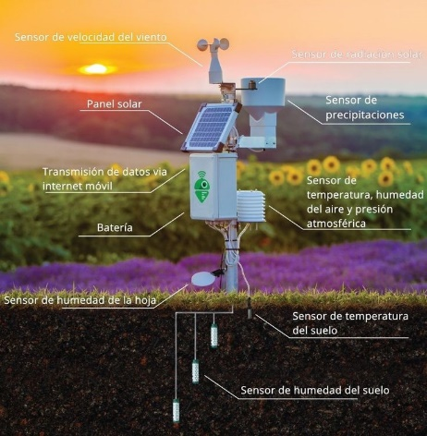

2.5 Livestock Tracking:
Smart IoT collars and ear tags are used to monitor the health and location of livestock. These devices track body temperature, heart rate, feeding patterns, and movement. Abnormal readings trigger automatic alerts to the farmer, enabling early detection of illness or stress — reducing livestock mortality and veterinary costs significantly.
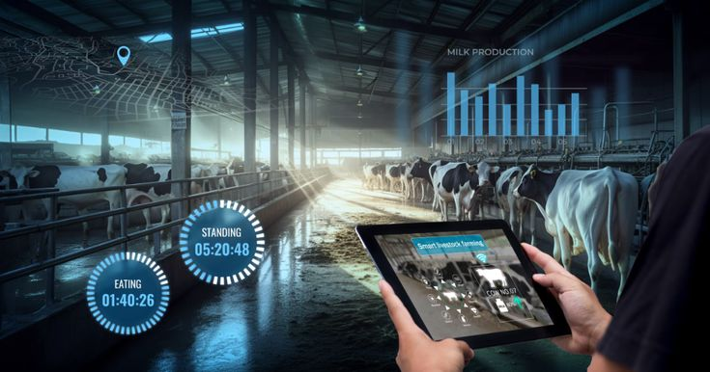

3. Benefits of IoT in Agriculture:
• Increased Productivity: Precision farming through IoT can increase crop yields by 15–20% by optimizing inputs like water, fertilizer, and pesticides.
• Resource Efficiency: Smart irrigation and sensor-based fertilization reduce water usage by up to 50% and chemical usage by 25%.
• Cost Reduction: Early detection of pests and diseases reduces crop losses and lowers expenditure on pesticides and labor.
• Data-Driven Decisions: Farmers gain access to historical and real-time data, enabling better planning and risk management.
• Environmental Sustainability: Reduced chemical runoff and optimized water usage contribute to environmental conservation.

4. Challenges and Limitations:
Despite its enormous potential, the adoption of IoT in agriculture — especially in developing countries — faces several significant hurdles:
• High Initial Cost: Sensors, drones, and connectivity infrastructure require substantial upfront investment, which is often beyond the reach of small-scale farmers.
• Connectivity Issues: Rural and remote areas often lack reliable internet or mobile network coverage, which is essential for IoT systems to function.
• Digital Literacy: Many farmers, particularly older generations, lack the technical skills to operate and maintain smart farming tools.
• Data Security: Farming data collected by IoT devices can be vulnerable to cyberattacks or misuse by third parties.
• Power Supply: Consistent electricity supply is necessary for IoT devices, which is often unreliable in rural Pakistan and similar regions.

5. Real-World Examples:
Several countries have successfully implemented IoT-based smart agriculture at scale:
Country / Region | Application | Outcome
Netherlands | Greenhouse IoT sensors & automation. | World's 2nd largest food exporter despite small land.
India | Smart irrigation via mobile-linked sensors. | 30–40% water saving in Maharashtra & Punjab.
Pakistan (PARC) | Precision agriculture pilot projects. | Improved wheat & cotton yield in pilot districts.
USA | John Deere GPS + IoT tractors. | Reduced fuel use and optimized planting patterns.

6. Future Outlook:
As the cost of sensors and connectivity continues to decrease, and as government and private initiatives expand rural internet access, IoT adoption in agriculture is expected to accelerate significantly. The integration of artificial intelligence with IoT data is already enabling predictive analytics, such as forecasting crop yields or anticipating pest outbreaks before they occur. Combined with technologies like 5G and autonomous farm machinery, IoT is poised to play a central role in building more resilient, efficient, and sustainable food production systems for a growing global population.
7. Conclusion:
IoT is rapidly transforming agriculture from a labor-intensive, unpredictable industry into a data-driven, efficient, and sustainable sector. Smart Agriculture technologies — including soil sensors, automated irrigation, drones, and livestock trackers — offer farmers the tools to increase yields, conserve resources, and reduce costs. For countries like Pakistan, where agriculture contributes nearly 23% to GDP and supports millions of livelihoods, embracing IoT in farming is not just an option — it is a necessity. With proper government investment, farmer training, and rural connectivity initiatives, Smart Agriculture can drive food security and economic growth for decades to come.

References:
• Tzounis, A., Katsoulas, N., Bartzanas, T., & Kittas, C. (2017).
Internet of Things in agriculture: Recent advances and future challenges.
Biosystems Engineering, 164, 31–48. https://doi.org/10.1016/j.biosystemseng.2017.09.007
• Farooq, M. S., Riaz, S., Abid, A., Umer, T., & Zikria, Y. B. (2020). Role of IoT technology in agriculture: A systematic literature review. Electronics, 9(2), 319. https://doi.org/10.3390/electronics9020319
• Food and Agriculture Organization (FAO). (2022). The Future of Food and Agriculture: Drivers and Triggers for Transformation. Rome: FAO.
• Pakistan Agricultural Research Council (PARC). (2023). Precision Agriculture and Smart Farming Initiatives in Pakistan. Islamabad: PARC.
• Verdouw, C., Wolfert, S., & Tekinerdogan, B. (2021). Internet of Things in agriculture. CAB Reviews, 16(035), 1–12.
https://doi.org/10.1079/PAVSNNR202116035
World Bank. (2023). Agriculture and Food: Overview.
- Trafalgar Wireless. "The Future of IoT in Agriculture: What Smart Farms Look Like."
Trafalgarwireless. com/blog/the-future-of-iot-in-agriculture.

